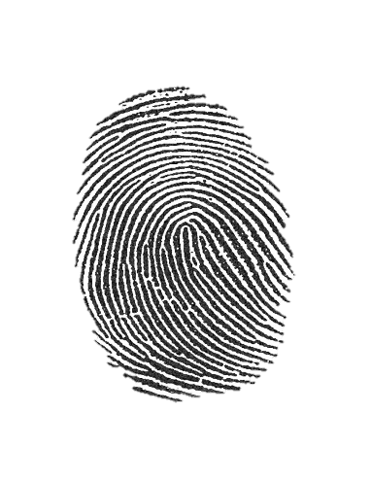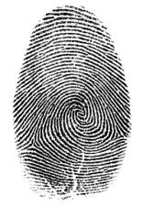

Minnie

Donald

Julianna

Mickey

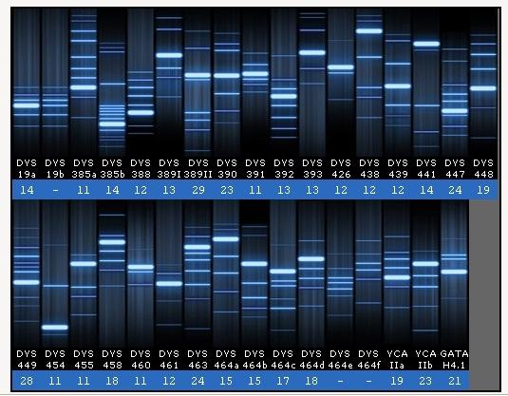

CS 16 Fingerprint #2- FOUND ON SAFE

CS15 Fingerprint #1 - FOUND ON DOORKNOB



DNA sample from dresser – CS17

These are the DNA samples from four people